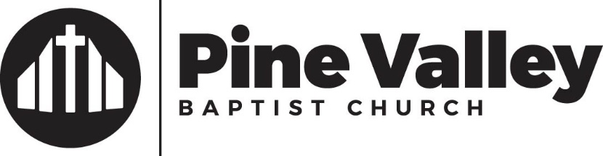

3940 Shipyard Blvd.
Wilmington, NC 28403

910-791-1949 ∙ Fax: 910-395-5576
pinevalleybc.org

News Release!!! March 3, 2024

We are excited to introduce Dr. Stephen J. Anthony as the new pastor of Pine Valley Baptist Church in Wilmington, North Carolina.

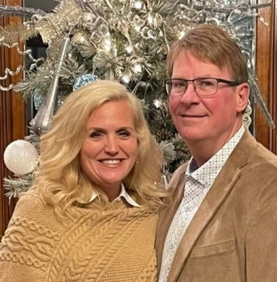

Dr. Stephen J. Anthony

Dr. Anthony comes to us from Hill Crest Baptist Church in Anniston, Alabama. He has a Doctor of Ministry from Trinity Theological Seminary, a Masters of Divinity from Southeastern Baptist Theological Seminary, and a Master of Arts in Religious Education from Liberty Baptist Theological Seminary.

Dr. Anthony and his wife, Jeanna, have North Carolina roots. Both come from ministerial families. His father was a Pastor until his retirement, and Jeanna’s father was a Minister of Music until his retirement. They have two adult daughters both who are serving as missionaries.

He comes to us with a wealth of experience in preaching, church growth, evangelism, and leadership.

Please join us in welcoming the Anthonys to Pine Valley and to Wilmington.

